Campus Map
16TH ST

MCME 15 TH ST
OUHSC STUDENT PARKING
15T
RESIDENT PARKING

15 TH ST

VA PARKING

14 TH ST
PATH
CHAN PK WY

14 TH ST
LINDSAY AV E
LINCOLN BLVD

OUMC

14E

13R
PHILLIPS AV E
1
13N

13T

3 TH ST

OU Medical Center
LOTTIE AV E

13P

13 TH ST 13 TH ST

13A

11P

13Q

13B
JB SAUNDERS

Residents
College of Public Health

13 TH ST
13R

13W
STONEWALL AV E
PHILLIPS AV E / CHILDREN’S AV E

13J
M ARK EV ER ET T DR

13L

13M
KELLE Y AV E

Resident Entrance

Residents Park on Levels 2-5

11Y
Park Here.
11N

11N
11N
College Health

12 TH ST

12M

12N
OUMC Clinics

OU College of Medicine Children’s Atrium
OU Children’s Physicians The Children’s Hospital Williams Pavilion
OU Physicians

Garrison
LOT TIE AV E

SL YOUNG BLVD

11A
LINDSAY AV E

11F

10K
College of Pharmacy
S TONE WALL AV E

OUHSC
EV ERES T AV E
Student Parking

Nicholson O’Donoghue
11N

PARK PL

Resident Entrance
PHILLIPS AV E

Park on Levels 3-5

Union

College of Nursing
11N

Turn here to enter Parking Lot 10K.

10P
10Q
10U
10W

University Village Apartments
8X

885

10 TH ST

840
800

University Research Park

865 825

755
PHILLIPS AV E
10 TH ST

10A

8P

8TH ST

10C

10B
RESE ARCH
10 TH ST

8T

8TH ST
8H

10K
LOT TIE AV E
S TONE WALL AV E
PHILLIPS AV E
LINCOLN BLVD

OUHSC Academic Buildings OUHSC Tunnels

Clinics

Patient/Visitor Parking Landmark Elevators Hospitals
Emergency Departments OUHSC Shuttle
OUMC Express Shuttle

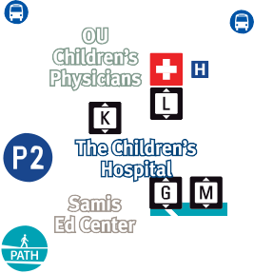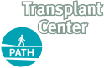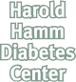

655
2 .6. 2018
LINCOLN BLVD
RESE ARCH PARK WAY

